KNN:
• Nearest neighbour algorithm,
• Simplest algorithm.
• Don't need to train any dataset.
• Distances between x numbers of data points.
• Non-parametric algorithm. - No assumptions are needed.
• Classification and Regression.
• k - value (find the best value for k) -> fine tune in k
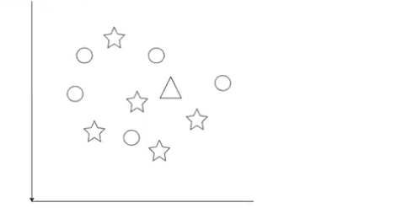
• k = 3, 5, 7 = Number of nearest neighbours (neighbour classes).
• odd values for k (not even)
• Prediction:
• Classification: Majority classes - Mode
• Regression: Averaging of the values.
• small value for k = Chances of Overfitting
• large value for k = Chances of underfitting.
• ie. you have to fine tune the value of k.

Distance:
• Euclidean distance - It calculates the distance by drawing
• a straight line between two data points.
• Manhattan distance - It flows path with right angle distance.
• Minkowski distance - Unit = 1 for distance calculate.

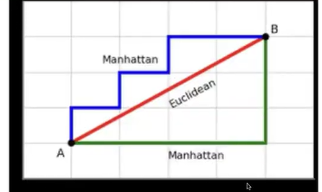

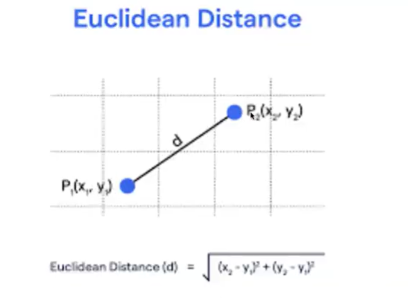

Use KNN classifier and KNN regression
Major drawback- id dataset is big/ large then compute/ calculating amnge data points take more time.
If outlier is available in data so result may not good.

Condition use: if feature is 2 or 3 and clean dataset available then use KNN

